

AMITY INSTITUTE OF INFORMATION TECHNOLOGY

Course Code : CSE2052

“INTRODUCTION TO ARTIFICAL INTELLIGENCE”

LABORATORY RECORD

Fall Semester – 2025-26

SUBMITTED TO:
DR MADHU BHAN
SUBMITTED BY:
ANANYA B
A86904824021
BCA

INDEX

Sl. No. | Date | Program | Page No.
1 | 24/09/2025 | SIMPLE AGENT | 3
2 | 24/09/2025 | SIMPLE AGENT | 4
3 | 08/10/2025 | PROBLEM REPRESENTATION | 5
4 | 08/10/2025 | SIMPLE AGENT | 6
5 | 15/10/2025 | GOAL BASED AGENT | 7-8
6 | 29/10/2025 | BREADTH FIRST SEARCH | 9-10
7 | 12/11/2025 | DEPTH FIRST SEARCH | 11-13
8 | 19/11/2025 | PROPOSITIONAL LOGIC | 14-15
9 | 19/11/2025 | PREDICATE LOGIC | 16-17
10 | 26/11/2025 | STATISTICAL MEASURES | 18
11 | 26/11/2025 | DATASET AND FEATURES | 19
12 | 03/12/2025 | MISSING VALUE HANDLING | 20
13 | 10/12/2025 | OUTLIER DETECTION | 21-22
14 | 10/12/2025 | TRAIN TEST SPLIT | 23
15 | 24/12/2025 | MIN MAX NORMALIZATION | 24
16 | 31/12/2025 | LINEAR REGRESSION | 25
17 | 07/01/2026 | BEST FIT REGRESSION LINE | 26-27
18 | 21/01/2026 | DECISION TREE | 28-29
19 | 28/01/2026 | LOGISTIC REGRESSION | 30-31

Program 1
Write a program where the agent decides an action based on conditions.
Example: If it is "sunny" → print "Wear sunglasses"; If it is "rainy" → print "Carry umbrella".
INPUT:
weather = input("Enter the weather (sunny, rainy, cloudy, cold): ").lower()
if weather == "sunny":
print("wear sunglasses")
elif weather == "rainy":
print("carry umbrella")
elif weather == "cloudy":
print("It might rain, better take a jacket")
elif weather == "cold":
print("wear a warm coat")
else:
print("No specific advice, enjoy your day!!")

OUTPUT:
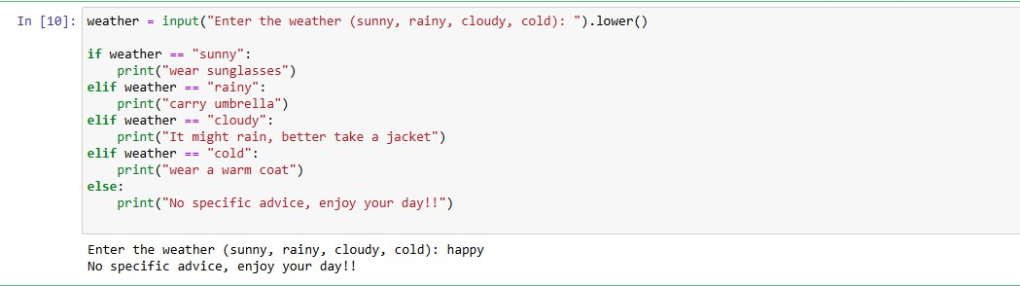

Program 2
Write a program where the agent decides an action based on temperature.
Example: If temp > 30 → print "Drink plenty of water"; else if temp > 20 → print "Weather is pleasant"; else if temp > 10 → print "Wear a jacket".
INPUT:
temp = int(input("Enter temperature: "))
if temp > 30:
print("Drink plenty of water")
elif temp > 20:
print("Weather is pleasant")
elif temp > 10:
print("Wear a jacket")
else:
print("It's very cold, stay warm")

OUTPUT:
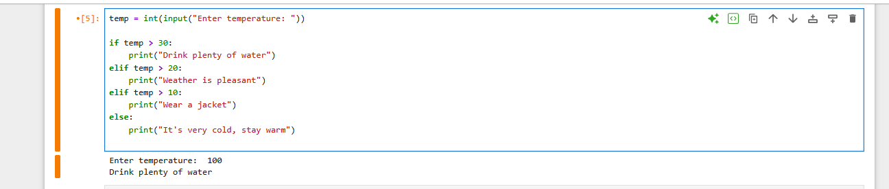

Program 3
Write a program for 8-Puzzle problem state representation (8-puzzle new).
Display as 3×3 matrix.
Compare initial state and goal state and if equal display "the two states are same", else display "the two states are different".
INPUT:
initial_state = [1, 2, 3, 4, 5, 6, 7, 8, "_"]
goal_state = [1, 2, 3, 4, 5, 6, 7, 8, "_"]
def display_state(state):
for i in range(0, len(state), 3):
print(state[i:i+3])
print()
print("Initial State:")
display_state(initial_state)
print("Goal State:")
display_state(goal_state)
if initial_state == goal_state:
print("The states are the same.")
else:
print("The states are different.")
OUTPUT:
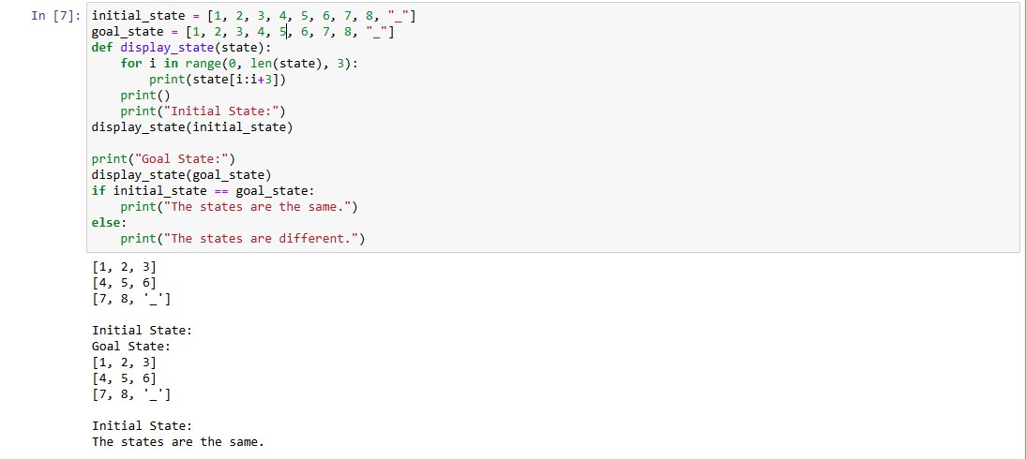
Program 4
Write a program to simulate a simple Vacuum Cleaner Agent that cleans two locations (A and B).
The agent should check if the current location is dirty — if so clean it; otherwise move to the next location.
Finally, display the initial and final environment.
INPUT:
room_status = input("Enter the status of the room (c/d): ").lower()
if room_status == "c":
print("Clean it properly")
elif room_status=="d":
print("move to next roon")
else:
print("Invalid input. Please enter 'dirty' or 'clean'.")

OUTPUT:
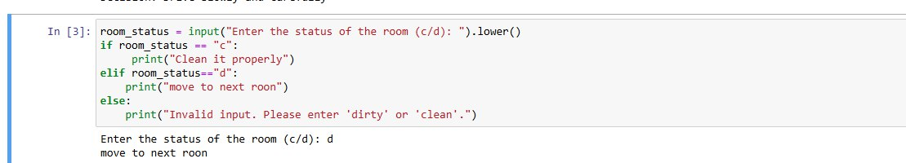

Program 5
Write a program to simulate an Autonomous Car Agent that can make driving decisions based on environmental conditions such as traffic light color, obstacle detection, and road condition.
The car should decide whether to move, stop, or slow down depending on the situation.
INPUT:
def autonomous_car_agent(traffic_light, obstacle, road_condition):
print("Traffic Light:", traffic_light)
print("Obstacle Detected:", obstacle)
print("Road Condition:", road_condition)
if traffic_light.lower() == "red":
action = "Stop the car"
elif traffic_light.lower() == "yellow":
action = "Slow down and prepare to stop"
elif obstacle.lower() == "yes":
action = "Stop — obstacle ahead"
elif road_condition.lower() == "slippery":
action = "Drive slowly and carefully"
elif traffic_light.lower() == "green" and obstacle.lower() == "no":
action = "Move forward safely"
else:
action = "Stay alert and maintain current state"
print("Decision:", action)
print("=== Scenario 1 ===")
autonomous_car_agent("Red", "No", "Clear")

print("\n=== Scenario 2 ===")
autonomous_car_agent("Green", "Yes", "Clear")
autonomous_car print("\n=== Scenario 3 ===")
_agent("Green", "No", "Slippery")
OUTPUT:
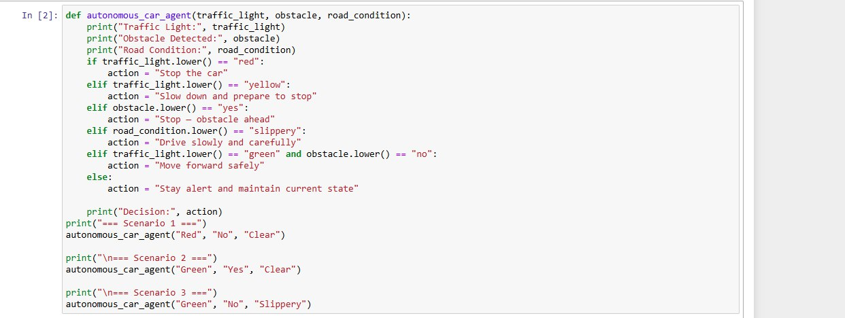
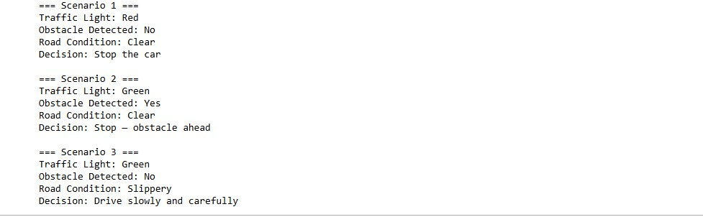

Program 6
Write a program that accepts an adjacency list of a graph as input and performs Breadth First Search (BFS) starting from a given source node.
The program should display the order in which the nodes are visited.
INPUT:
n = int(input("Enter the number of nodes: "))
nodes = []
print("Enter the node names:")
for i in range(n):
name = input(f"Node {i}: ")
nodes.append(name)
graph = {}
print("\nEnter the adjacent nodes for each node (space-separated). If none, press Enter:")
for node in nodes:
neighbors = input(f"Neighbors of {node}: ").split()
graph[node] = neighbors
print("\nAdjacency List Representation:")
for node in graph:
print(node, "->", ", ".join(graph[node]))
start = input("\nEnter the starting node for BFS: ")
visited = []
queue = []
visited.append(start)
queue.append(start)

print("\nBFS Traversal Order:", end=" ")
while queue:
current = queue.pop(0)
print(current, end=" ")

for neighbor in graph[current]:
if neighbor not in visited:
visited.append(neighbor)
queue.append(neighbor)

print()

OUTPUT:
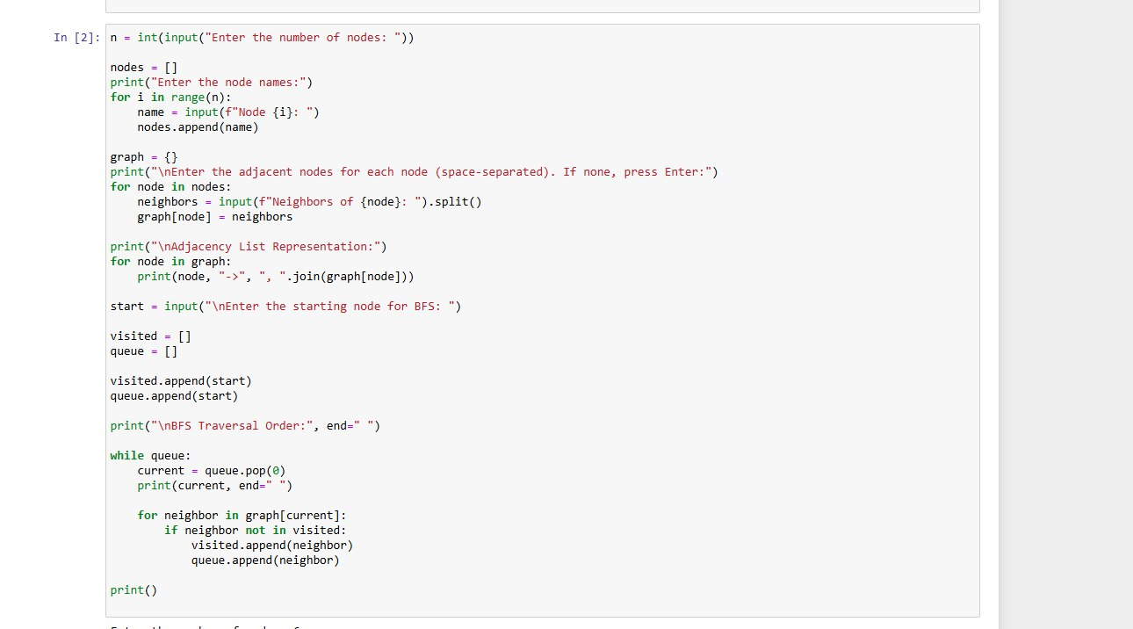
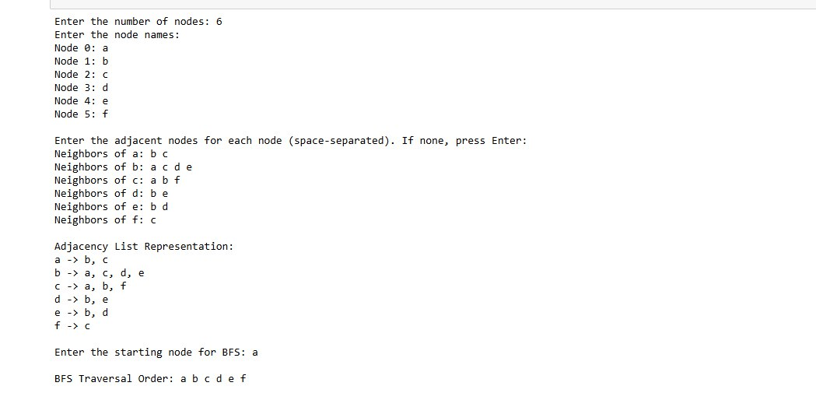
Program 7
Write a program that accepts an adjacency list of a graph as input and performs Depth First Search (DFS) starting from a given source node.
The program should display the order in which the nodes are visited.
INPUT:
n = int(input("Enter the number of nodes: "))
nodes = []

print("Enter the node names:")
for i in range(n):
name = input(f"Node {i+1} name: ")
nodes.append(name)

graph = {}

print("\nEnter the adjacent nodes for each node (separated by space):")
for node in nodes:
neighbors = input(f"Neighbors of {node}: ").replace(",", " ").split()
graph[node] = neighbors

print("\nAdjacency List Representation:")
for node in graph:
print(node, "->", ", ".join(graph[node]))

start = input("\nEnter the starting node for DFS: ")

visited = []
stack = [start]

print("\nDFS Traversal Order:", end=" ")
while stack:
node = stack.pop() # pop from end → DFS
if node not in visited:
print(node, end=" ")
visited.append(node)

# push neighbors in reverse so left-most is processed first
for neighbor in reversed(graph[node]):
if neighbor not in visited:
stack.append(neighbor)

print()
OUTPUT:
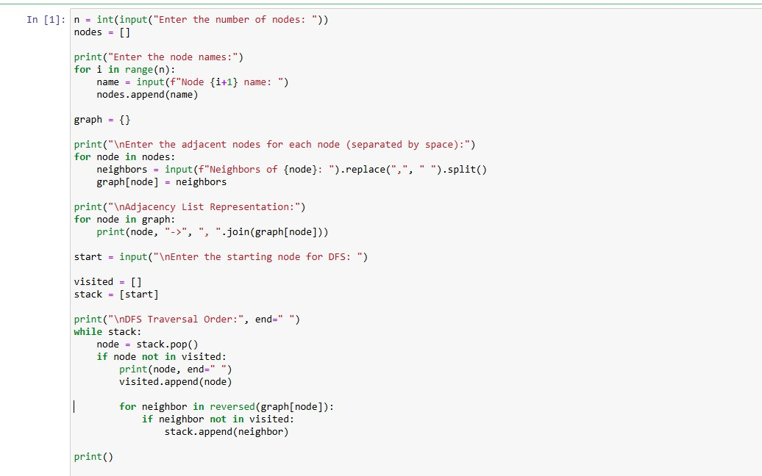
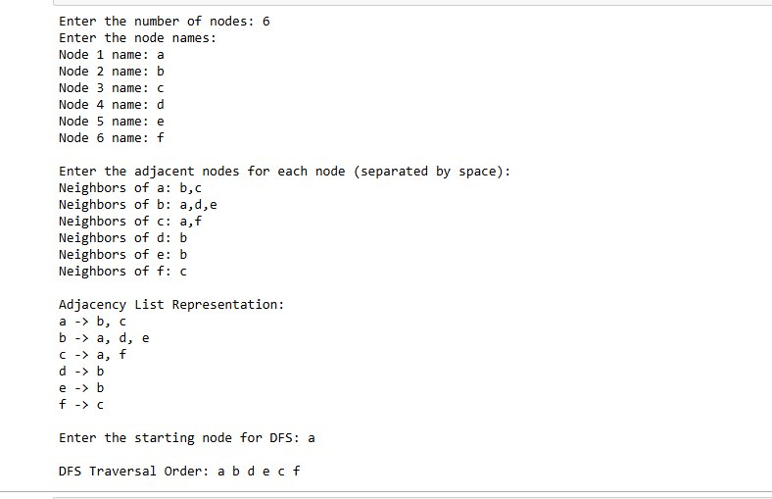

Program 8
Write a program to evaluate basic propositional logic expressions.
The user should enter truth values (True/False) for propositions P and Q.
The program should compute and display the results of the following logical operations:
P AND Q
P OR Q
NOT P
P → Q (Implication)
INPUT:
print("Enter the truth values for P and Q (True/False):")
P_input = input("Enter P (True/False): ")
Q_input = input("Enter Q (True/False): ")

# Convert string input to boolean
if P_input == "True":
P = True
else:
P = False

if Q_input == "True":
Q = True
else:
Q = False

# Logical operations
and_result = P and Q
or_result = P or Q
not_result = not P
implication_result = (not P) or Q
biconditional_result = (P and Q) or ((not P) and (not Q))

# Display results
print("\n----Results----")
print("P and Q =", and_result)
print("P or Q =", or_result)
print("not P =", not_result)
print("P -> Q =", implication_result)
print("P <-> Q =", biconditional_result)
OUTPUT:
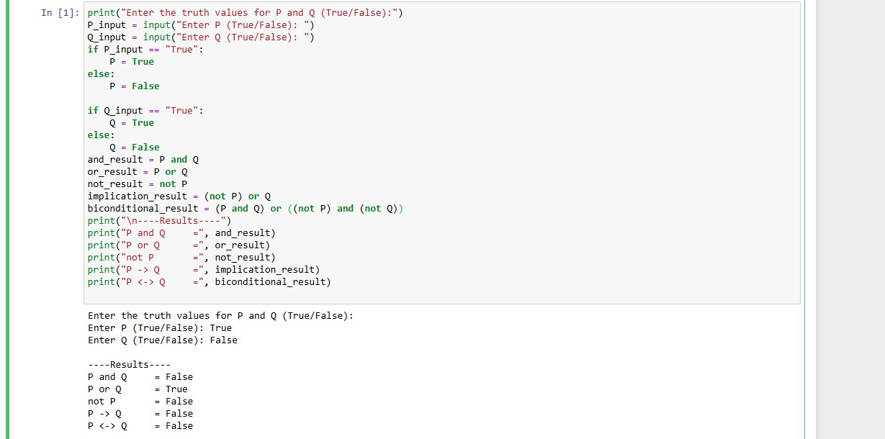

Program 9
Write a program that stores a few predicate facts (like parent, brother, teacher) using simple lists.
The user will enter a query such as: parent(John, Mary).
The program should check whether this fact exists in the list and print: Fact exists / Fact does NOT exist.
INPUT:
parent_facts=[("John"."Mary"),("Ravi","Amit")]
brother_facts=[("Amit"."Rohan"),("Rohan","Amit")]
teacher_facts=[("Seema"."Class5"),("Arun","Class3")]
print("Enter a query like: parent(John,Mary)")
quer= input("Query: ")
parts= query.split("(")
predicate=parts[0]
args = pary[1].replace(")","")
arg1, arg2 = args.split(",")
arg1= arg1.strip()
arg2= arg2.strip()
fact_exists = False
if predicate == "parent":
facts = parent_facts
elif predicate == "brother":
facts = brother_facts
elif predicate == "teacher":
facts = teacher_facts
else:
print("Unknown predicate:", predicate)
exit()
if (arg1, arg2) in facts:
fact_exists = True
if fact_exists:
print(f"YES, {predicate}({arg1},{arg2}) is TRUE")
else:
print(f"NO, {predicate}({arg1},{arg2}) is FALSE")

OUTPUT:
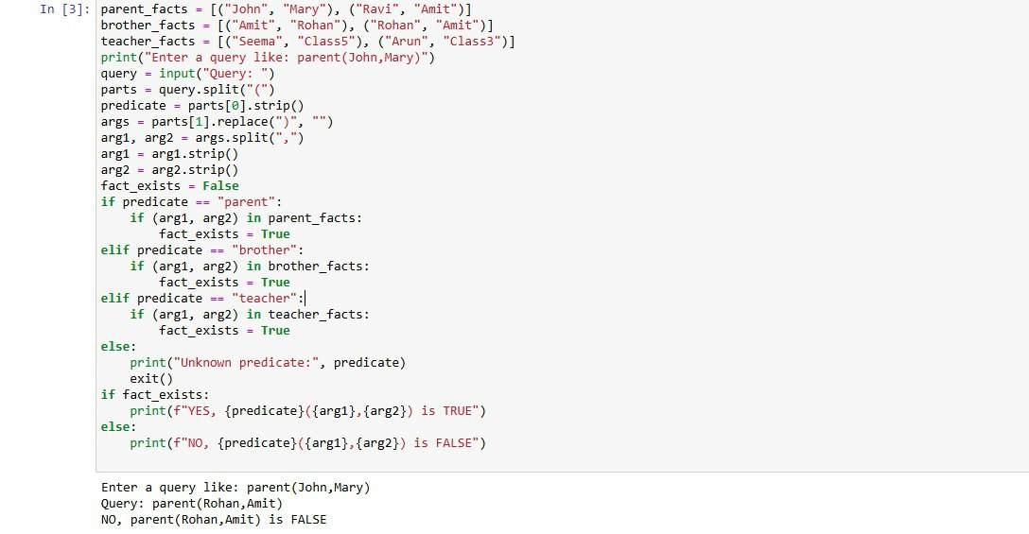

Program 10
Find Mean, Median, Mode, and Standard Deviation of a given dataset:
speed = [99, 86, 87, 88, 111, 86, 103, 87, 94, 78, 77, 85, 86]
INPUT:
import numpy
from scipy import stats
speed = [99, 86, 87, 88, 111, 86, 103, 87, 94, 78, 77, 85, 86]
x = numpy.mean(speed)
y = numpy.median(speed)
z = stats.mode(speed)
p = numpy.std(speed)
print("mean is", x)
print("median is", y)
print("mode is", z)
print("std is", p)

OUTPUT:
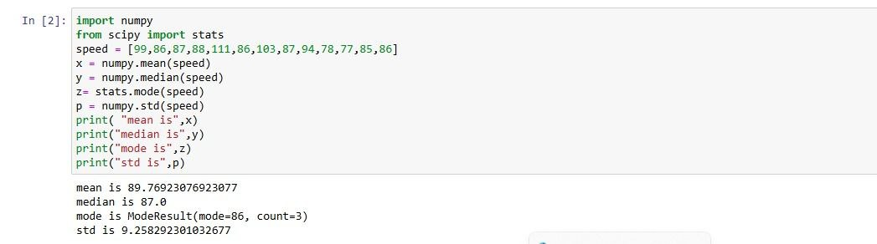

Program 11
Write a program to demonstrate the concept of a dataset and features.
Create a small dataset, identify the feature and target values, and display them separately.
INPUT:
import numpy as np
# Step 1: Create a simple dataset
x = np.array([1, 2, 3, 4]) # Feature (1-D)
y = np.array([10, 20, 30, 40]) # Target / Label
print("Feature before reshape (1-D):")
print(x)
print("Shape:", x.shape)
# Step 2: Reshape feature into 2-D
x = x.reshape(-1, 1)
print("\nFeature after reshape (2-D):")
print(x)
print("Shape:", x.shape)

OUTPUT:
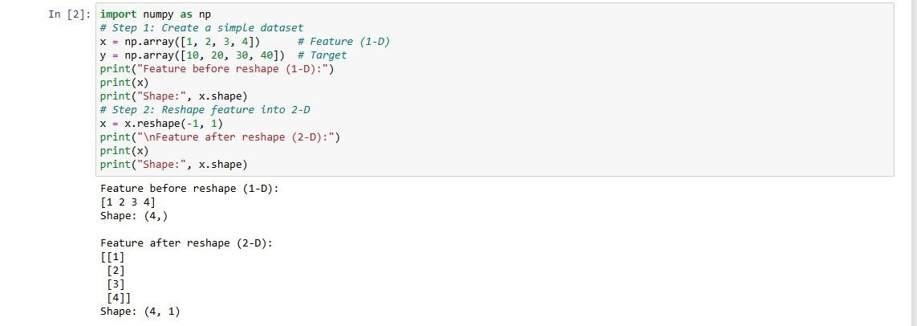

Program 12
Design a program to demonstrate the use of SimpleImputer class for filling the missing values.
INPUT:
In [9]: from sklearn.impute import SimpleImputer
import numpy as np
from scipy import stats
data = np.array([
[10, 2],
[15, np.nan],
[np.nan, 4],
[20, 5]
])
print("Original Data:")
print(data)
imputer = SimpleImputer(strategy='most_frequent')
imputed_data = imputer.fit_transform(data)
print("\nData After Imputation:")
print(imputed_data)
OUTPUT:
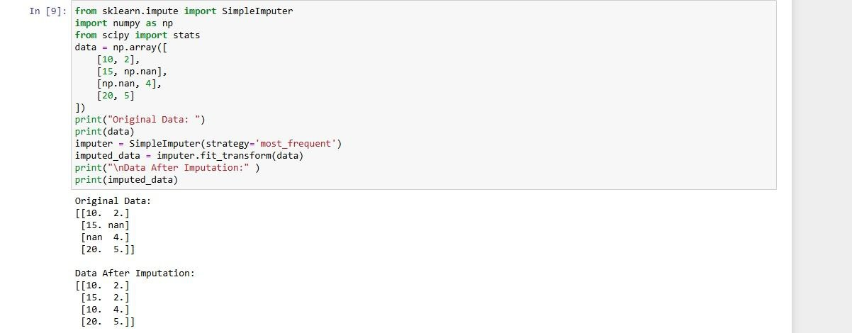
Program 13
Write a program to find outliers using Z-score.
INPUT:
import numpy as np
from scipy import stats
# Step 1: Create a dataset
data = [10, 12, 14, 15, 16, 18, 20, 22, 24, 100]
# Step 2: Calculate Z-scores
z_scores = stats.zscore(data)
# Step 3: Set threshold
threshold = 3
# Step 4: Find outliers
outliers = []
for i in range(len(data)):
if abs(z_scores[i]) > threshold:
outliers.append(data[i])
# Step 5: Display results
print("Data:", data)
print("Z-scores:", z_scores)
print("Outliers:", outliers)

OUTPUT:
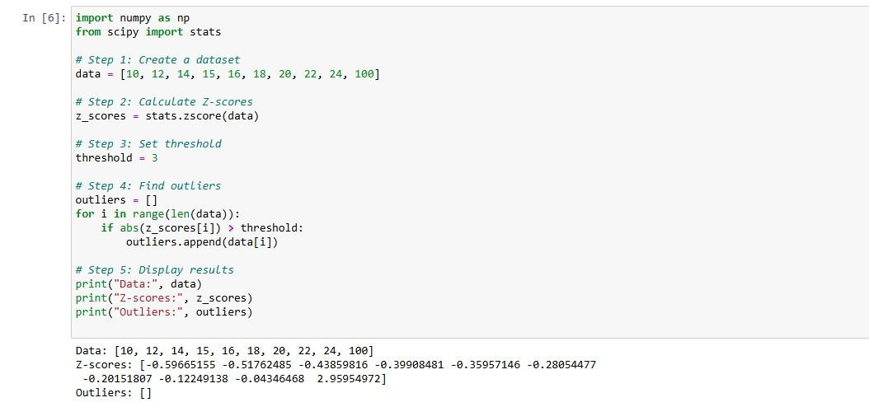

Program 14
Design a program to demonstrate how a dataset is divided into training data and testing data using the train_test_split() function from the scikit-learn library.
INPUT:
import numpy as np
from sklearn.model_selection import train_test_split
x = np.array([800, 1000, 1200, 1500, 1800]).reshape(-1, 1)
y = np.array([120, 150, 180, 210, 250])
x_train, x_test, y_train, y_test = train_test_split(
x, y, test_size=0.2, random_state=42
)
print("x_train:", x_train)
print("y_train:", y_train)
print("x_test:", x_test)
print("y_test:", y_test)
OUTPUT:
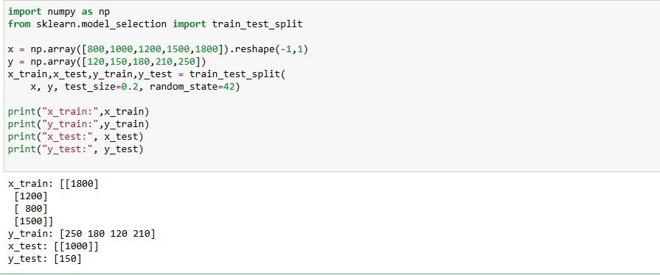

Program 15
Given the following dataset representing marks scored by students:
[10, 12, 14, 15, 16, 18, 20, 22, 24]
Write a program to perform Min-Max Normalization to scale the data between 0 and 1.
INPUT:
import numpy as np
data = np.array([10, 12, 14, 15, 16, 18, 20, 22, 24])
data_min = np.min(data)
data_max = np.max(data)
normalized_data = (data - data_min) / (data_max - data_min)
print("Original Data:", data)
print("Minimum Value:", data_min)
print("Maximum Value:", data_max)
print("Normalized Data:", normalized_data)

OUTPUT:
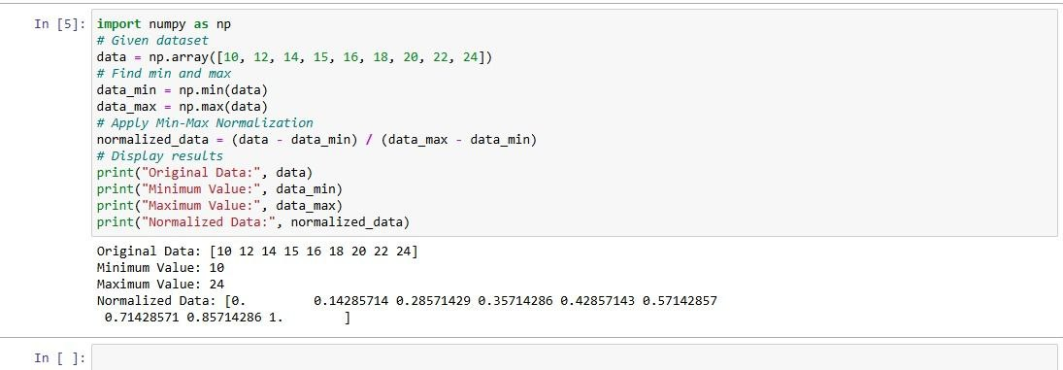

Program 16
Design a simple program to implement Simple Linear Regression using Python and scikit-learn to predict house prices based on house size.

INPUT:
import numpy as np
X = np.array([500, 800, 1000, 1200, 1500])
y = np.array([20, 30, 40, 50, 65])
mean_x = np.mean(X)
mean_y = np.mean(y)
m = sum((X - mean_x) * (y - mean_y)) / sum((X - mean_x) ** 2)
c = mean_y - m * mean_x
size = int(input("Enter house size in sqft: "))
price = m * size + c
print("Predicted House Price =", round(price, 2), "lakhs")

OUTPUT:
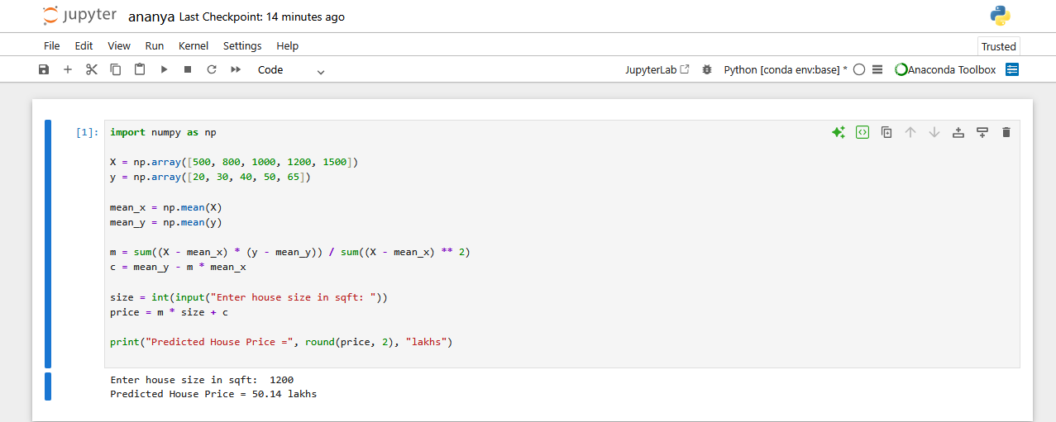

Program 17
Design and Develop a Python program to draw the best fit regression line.
INPUT:
import numpy as np
import matplotlib.pyplot as plt
from scipy import stats
x = [1, 2, 3, 4, 5, 6]
y = [0.4, 1.0, 1.7, 2.0, 2.2, 3.0]
slope, intercept, r, p, std_err = stats.linregress(x, y)
print("Slope:", slope)
print("Intercept:", intercept)
def myfunc(x):
return slope * x + intercept
mymodel = list(map(myfunc, x))
plt.scatter(x, y)
plt.plot(x, mymodel)
plt.xlabel("X values")
plt.ylabel("Y values")
plt.title("Best Fit Regression Line")
plt.show()

OUTPUT:
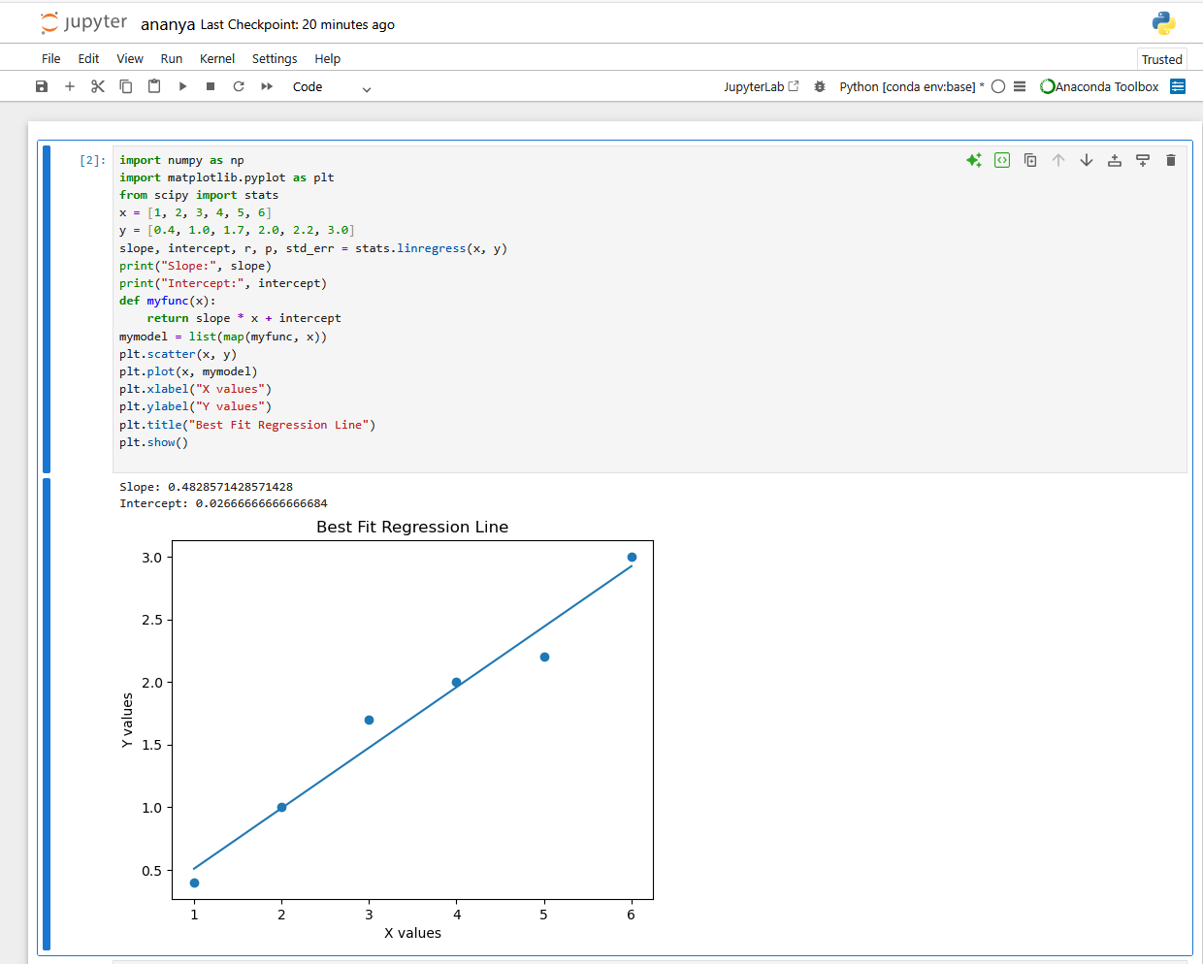

Program 18
Design and Develop a program that uses a Decision Tree classifier to predict diabetes outcomes.
INPUT:
from sklearn.tree import DecisionTreeClassifier
# Sample dataset: [Glucose, BMI, Age]
X = [
[120, 25, 30],
[150, 30, 45],
[90, 22, 25],
[180, 35, 50],
[110, 24, 28]
]
# Output: 1 = Diabetic, 0 = Not Diabetic
y = [0, 1, 0, 1, 0]
# Create model
model = DecisionTreeClassifier()
model.fit(X, y)
# User input
g = int(input("Enter glucose level: "))
b = int(input("Enter BMI: "))
a = int(input("Enter age: "))
result = model.predict([[g, b, a]])
if result[0] == 1:
print("Person is Diabetic")
else:
print("Person is Not Diabetic")

OUTPUT:
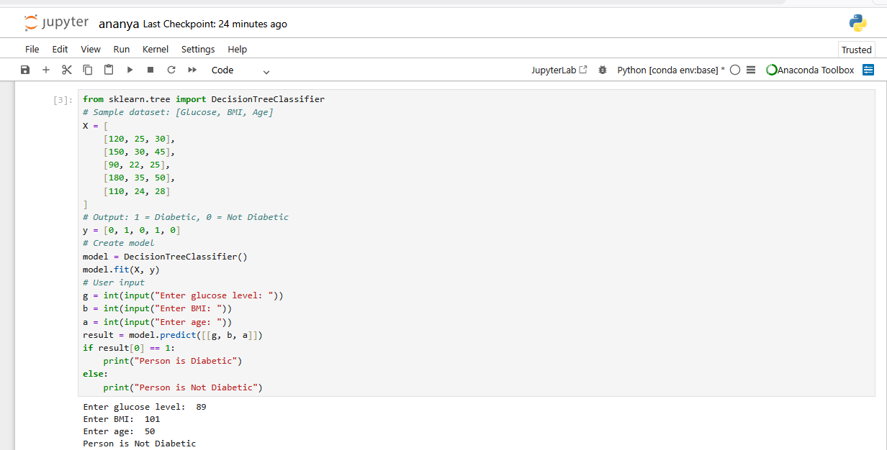

Program 19
Write a program to implement Logistic Regression for a binary classification problem that predicts whether a student passes or fails based on the number of hours studied.
INPUT:
from sklearn.linear_model import LogisticRegression
# Study hours
X = [[1], [2], [3], [4], [5], [6], [7]]
# Result: 0 = Fail, 1 = Pass
y = [0, 0, 0, 1, 1, 1, 1]
# Create model
model = LogisticRegression()
model.fit(X, y)
# User input
hours = int(input("Enter hours studied: "))
result = model.predict([[hours]])
if result[0] == 1:
print("Student Passed")
else:
print("Student Failed")

OUTPUT:
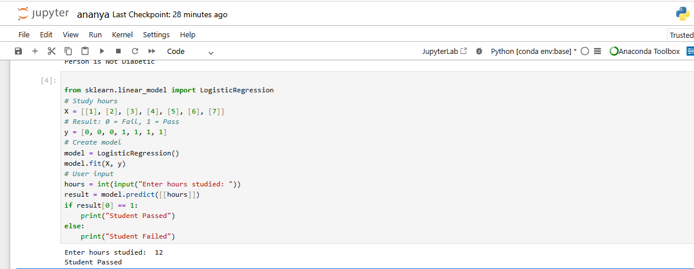

THANK YOU

